Appendix B-1

Simply supported square plate. 1/4 sym. Plate overall dimensions 2" X 2"
QUAD4 is MIN4T element

Plate thickness 0.02” (thin)

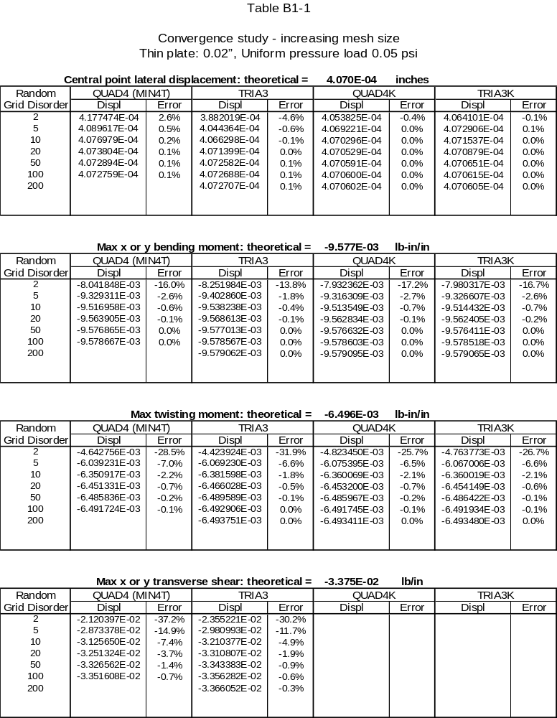

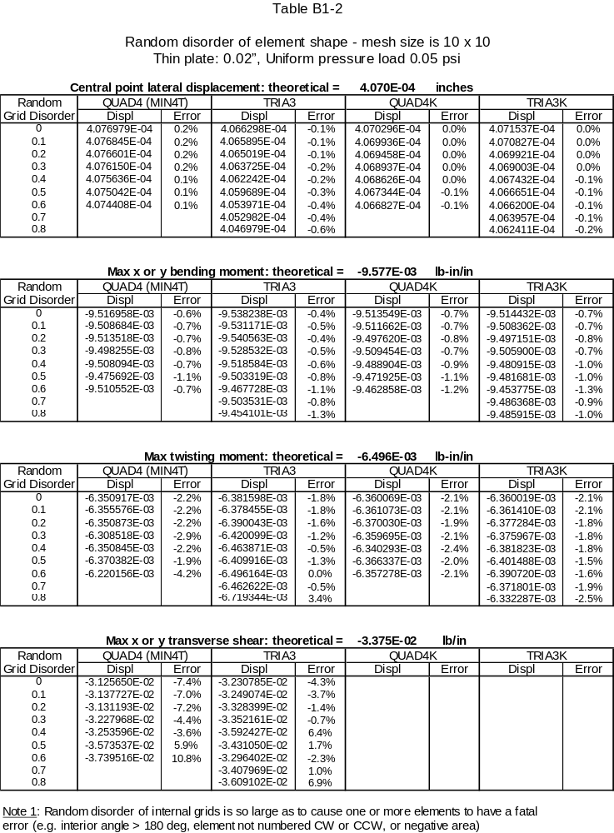

Appendix B-2

Simply supported square plate. 1/4 sym. Plate overall dimensions 2" X 2"
QUAD4 is MIN4T element

Plate thickness 0.20” (thick)
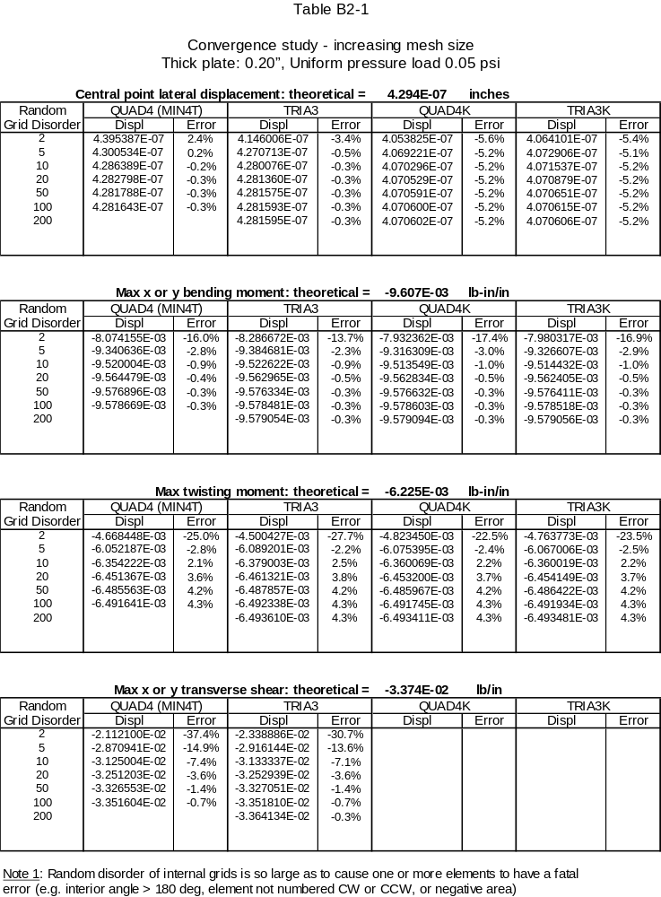

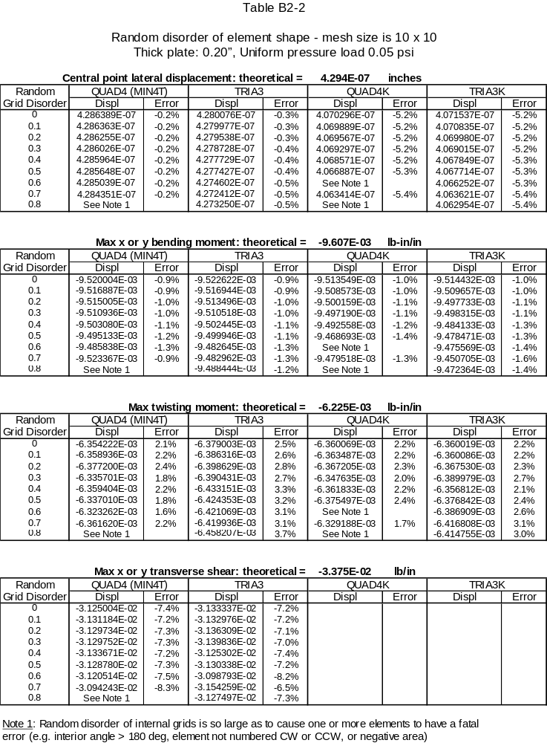
)

Appendix B-3

Square plate supported only at the central point. 1/4 sym.
Plate overall dimensions 2" X 2"
QUAD4 is MIN4T element

Plate thickness 0.02” (thin)

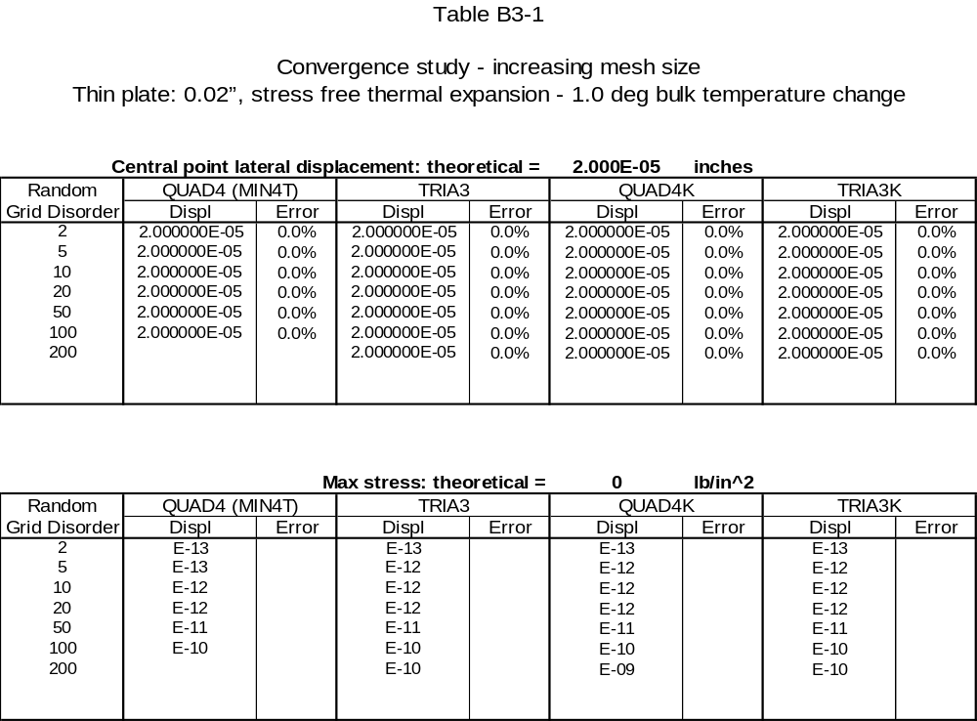

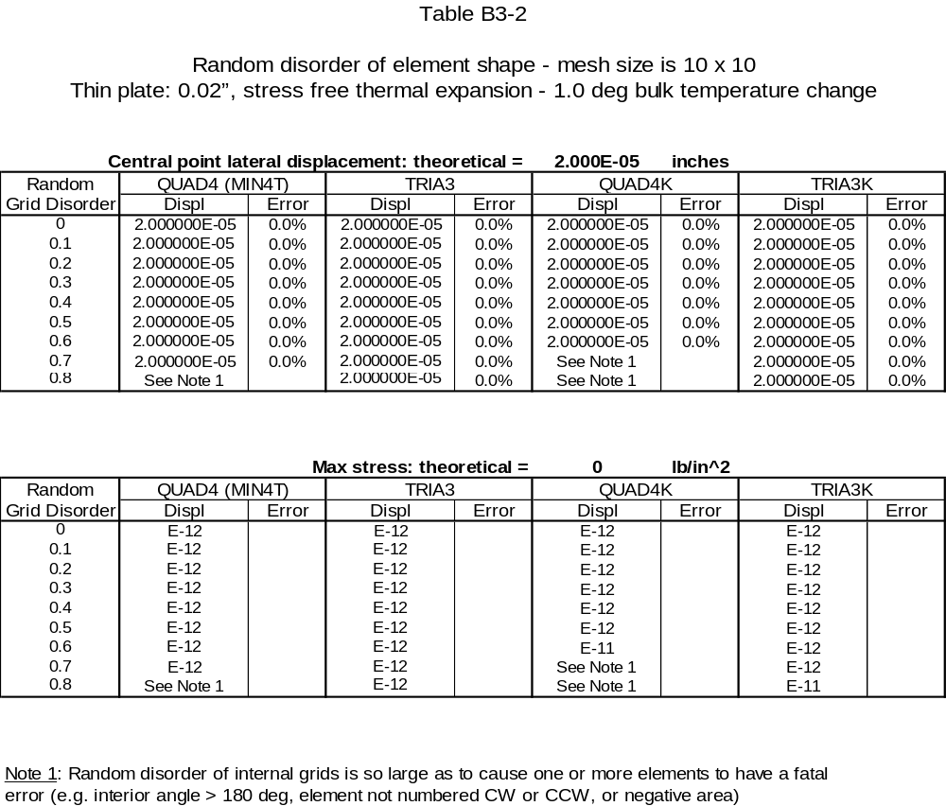

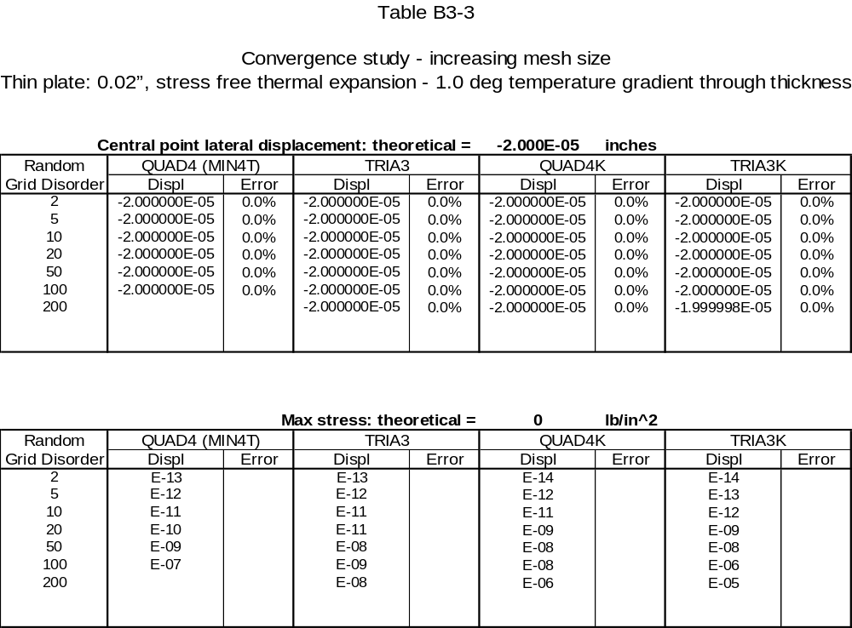

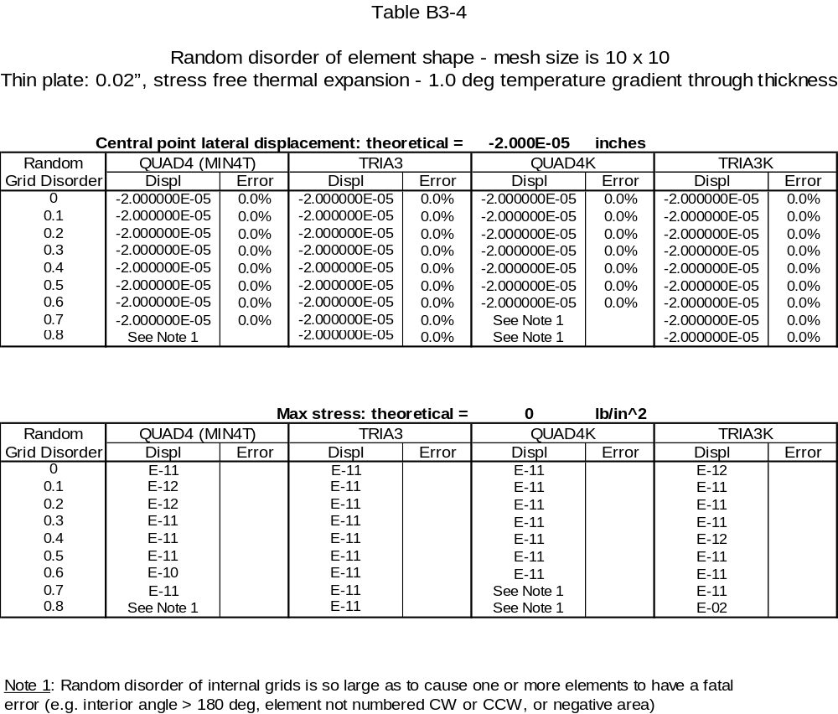

Appendix B-4

Square plate supported only at the central point. 1/4 sym.
Plate overall dimensions 2" X 2"
QUAD4 is MIN4T element

Plate thickness 0.20” (thick)

